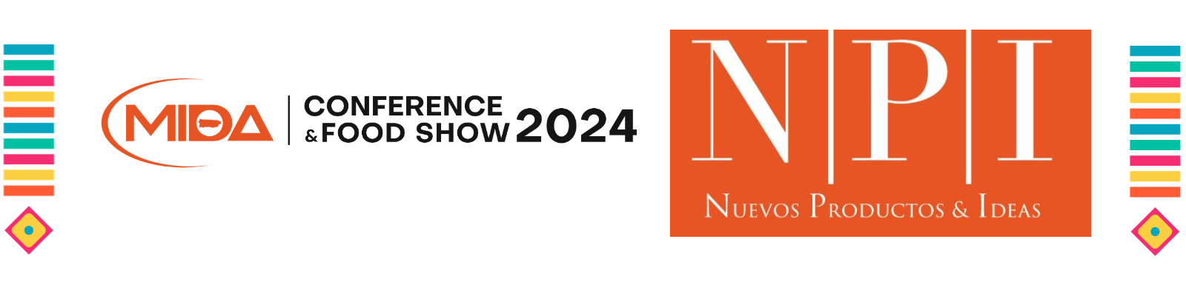
Please complete the following form and submit it with the
IMAGE OF THE PRODUCT DESCRIBED.

Company/Distributor: Click or tap here to enter text.
Contact (sales): Click or tap here to enter text.
Telephone: Click or tap here to enter text.
E-mail: Click or tap here to enter text.
Website: Click or tap here to enter text.
Product’s name: Click or tap here to enter text.
Description (35 words maximum ):
Click or tap here to enter text.

Important: All non-perishable products listed in the NPI catalog will be displayed in a special area during the three days of the Convention. Please notify us if you want to pick them up at the end of the event.

